|  |  |
| --- | --- |
| Date | 23st October 2022 |
| Team ID | PNT2022TMID40560 |
| Project Name | Gas Leakage Monitoring and Alerting System |
| Maximum Mark | 2 marks |

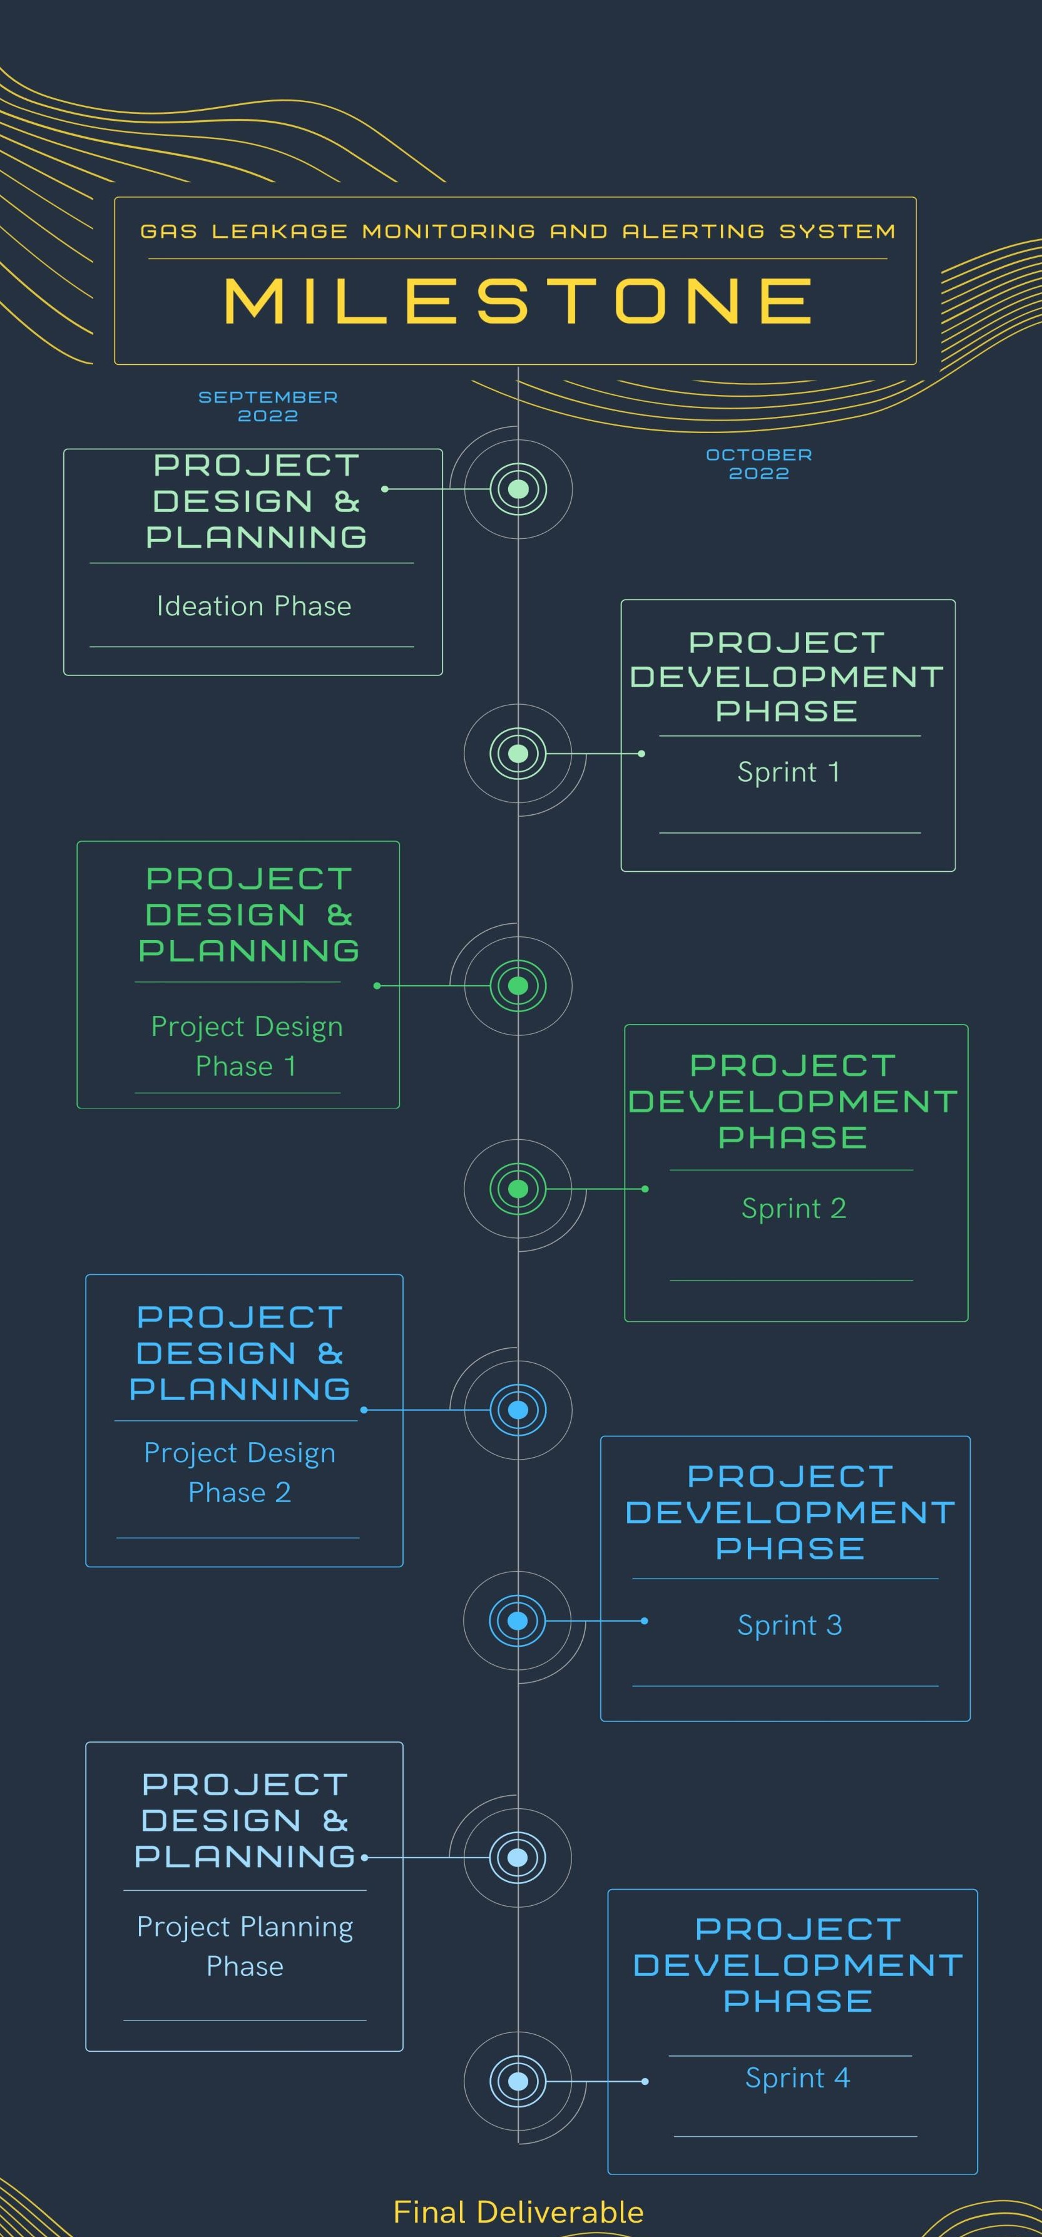

***Karthick P, Manikandan C ,Vijayakumar V, Venkatesh R***